**Final Year B. Tech., Sem VI 2022-23**

**cryptography and network security Lab**

**PRN No: 2019BTECS00071**

**Name: Charpale Abhishek Parmanand**

**Batch: B3**

**Assignment 6 : Data encryption standard**

**Aim:** To Demonstrate Data encryption standard

**Theory:**

The Data Encryption Standard (DES) is a symmetric-key block cipher published by the National Institute of Standards and Technology (NIST). DES is an implementation of a Feistel Cipher. It uses a 16 round Feistel structure. The block size is 64-bit. Though, key length is 64-bit, DES has an effective key length of 56 bits, since 8 of the 64 bits of the key are not used by the encryption algorithm.

**Procedure:**

1. In the first step, the 64-bit plain text block is handed over to an initial Permutation (IP) function.
2. The initial permutation is performed on plain text.
3. Next, the initial permutation (IP) produces two halves of the permuted block; saying Left Plain Text (LPT) and Right Plain Text (RPT).
4. Now each LPT and RPT go through 16 rounds of the encryption process.
5. In the end, LPT and RPT are rejoined and a Final Permutation (FP) is performed on the combined block
6. The result of this process produces 64-bit ciphertext.

**Code:**

**#include <bits/stdc++.h>**

**using namespace std;**

**string hex2bin(string s)**

**{**

**unordered_map<char, string> mp;**

**mp['0'] = "0000";**

**mp['1'] = "0001";**

**mp['2'] = "0010";**

**mp['3'] = "0011";**

**mp['4'] = "0100";**

**mp['5'] = "0101";**

**mp['6'] = "0110";**

**mp['7'] = "0111";**

**mp['8'] = "1000";**

**mp['9'] = "1001";**

**mp['A'] = "1010";**

**mp['B'] = "1011";**

**mp['C'] = "1100";**

**mp['D'] = "1101";**

**mp['E'] = "1110";**

**mp['F'] = "1111";**

**string bin = "";**

**for (int i = 0; i < s.size(); i++)**

**{**

**bin += mp[s[i]];**

**}**

**return bin;**

**}**

**string bin2hex(string s)**

**{**

**unordered_map<string, string> mp;**

**mp["0000"] = "0";**

**mp["0001"] = "1";**

**mp["0010"] = "2";**

**mp["0011"] = "3";**

**mp["0100"] = "4";**

**mp["0101"] = "5";**

**mp["0110"] = "6";**

**mp["0111"] = "7";**

**mp["1000"] = "8";**

**mp["1001"] = "9";**

**mp["1010"] = "A";**

**mp["1011"] = "B";**

**mp["1100"] = "C";**

**mp["1101"] = "D";**

**mp["1110"] = "E";**

**mp["1111"] = "F";**

**string hex = "";**

**for (int i = 0; i < s.length(); i += 4)**

**{**

**string ch = "";**

**ch += s[i];**

**ch += s[i + 1];**

**ch += s[i + 2];**

**ch += s[i + 3];**

**hex += mp[ch];**

**}**

**return hex;**

**}**

**string permute(string k, int *arr, int n)**

**{**

**string per = "";**

**for (int i = 0; i < n; i++)**

**{**

**per += k[arr[i] - 1];**

**}**

**return per;**

**}**

**string shift_left(string k, int shifts)**

**{**

**string s = "";**

**for (int i = 0; i < shifts; i++)**

**{**

**for (int j = 1; j < 28; j++)**

**{**

**s += k[j];**

**}**

**s += k[0];**

**k = s;**

**s = "";**

**}**

**return k;**

**}**

**string xor_(string a, string b)**

**{**

**string ans = "";**

**for (int i = 0; i < a.size(); i++)**

**{**

**if (a[i] == b[i])**

**{**

**ans += "0";**

**}**

**else**

**{**

**ans += "1";**

**}**

**}**

**return ans;**

**}**

**string encrypt(string pt, vector<string> rkb,**

**vector<string> rk)**

**{**

**pt = hex2bin(pt);**

**int initial_perm[64] = {58, 50, 42, 34, 26, 18, 10, 2, 60, 52, 44,**

**36, 28, 20, 12, 4, 62, 54, 46, 38, 30, 22,**

**14, 6, 64, 56, 48, 40, 32, 24, 16, 8, 57,**

**49, 41, 33, 25, 17, 9, 1, 59, 51, 43, 35,**

**27, 19, 11, 3, 61, 53, 45, 37, 29, 21, 13,**

**5, 63, 55, 47, 39, 31, 23, 15, 7};**

**pt = permute(pt, initial_perm, 64);**

**cout << "After initial permutation: " << bin2hex(pt)**

**<< endl;**

**string left = pt.substr(0, 32);**

**string right = pt.substr(32, 32);**

**cout << "After splitting: L0=" << bin2hex(left)**

**<< " R0=" << bin2hex(right) << endl;**

**int exp_d[48] = {32, 1, 2, 3, 4, 5, 4, 5, 6, 7, 8, 9,**

**8, 9, 10, 11, 12, 13, 12, 13, 14, 15, 16, 17,**

**16, 17, 18, 19, 20, 21, 20, 21, 22, 23, 24, 25,**

**24, 25, 26, 27, 28, 29, 28, 29, 30, 31, 32, 1};**

**int s[8][4][16] = {**

**{14, 4, 13, 1, 2, 15, 11, 8, 3, 10, 6, 12, 5,**

**9, 0, 7, 0, 15, 7, 4, 14, 2, 13, 1, 10, 6,**

**12, 11, 9, 5, 3, 8, 4, 1, 14, 8, 13, 6, 2,**

**11, 15, 12, 9, 7, 3, 10, 5, 0, 15, 12, 8, 2,**

**4, 9, 1, 7, 5, 11, 3, 14, 10, 0, 6, 13},**

**{15, 1, 8, 14, 6, 11, 3, 4, 9, 7, 2, 13, 12,**

**0, 5, 10, 3, 13, 4, 7, 15, 2, 8, 14, 12, 0,**

**1, 10, 6, 9, 11, 5, 0, 14, 7, 11, 10, 4, 13,**

**1, 5, 8, 12, 6, 9, 3, 2, 15, 13, 8, 10, 1,**

**3, 15, 4, 2, 11, 6, 7, 12, 0, 5, 14, 9},**

**{10, 0, 9, 14, 6, 3, 15, 5, 1, 13, 12,**

**7, 11, 4, 2, 8, 13, 7, 0, 9, 3, 4,**

**6, 10, 2, 8, 5, 14, 12, 11, 15, 1, 13,**

**6, 4, 9, 8, 15, 3, 0, 11, 1, 2, 12,**

**5, 10, 14, 7, 1, 10, 13, 0, 6, 9, 8,**

**7, 4, 15, 14, 3, 11, 5, 2, 12},**

**{7, 13, 14, 3, 0, 6, 9, 10, 1, 2, 8, 5, 11,**

**12, 4, 15, 13, 8, 11, 5, 6, 15, 0, 3, 4, 7,**

**2, 12, 1, 10, 14, 9, 10, 6, 9, 0, 12, 11, 7,**

**13, 15, 1, 3, 14, 5, 2, 8, 4, 3, 15, 0, 6,**

**10, 1, 13, 8, 9, 4, 5, 11, 12, 7, 2, 14},**

**{2, 12, 4, 1, 7, 10, 11, 6, 8, 5, 3, 15, 13,**

**0, 14, 9, 14, 11, 2, 12, 4, 7, 13, 1, 5, 0,**

**15, 10, 3, 9, 8, 6, 4, 2, 1, 11, 10, 13, 7,**

**8, 15, 9, 12, 5, 6, 3, 0, 14, 11, 8, 12, 7,**

**1, 14, 2, 13, 6, 15, 0, 9, 10, 4, 5, 3},**

**{12, 1, 10, 15, 9, 2, 6, 8, 0, 13, 3, 4, 14,**

**7, 5, 11, 10, 15, 4, 2, 7, 12, 9, 5, 6, 1,**

**13, 14, 0, 11, 3, 8, 9, 14, 15, 5, 2, 8, 12,**

**3, 7, 0, 4, 10, 1, 13, 11, 6, 4, 3, 2, 12,**

**9, 5, 15, 10, 11, 14, 1, 7, 6, 0, 8, 13},**

**{4, 11, 2, 14, 15, 0, 8, 13, 3, 12, 9, 7, 5,**

**10, 6, 1, 13, 0, 11, 7, 4, 9, 1, 10, 14, 3,**

**5, 12, 2, 15, 8, 6, 1, 4, 11, 13, 12, 3, 7,**

**14, 10, 15, 6, 8, 0, 5, 9, 2, 6, 11, 13, 8,**

**1, 4, 10, 7, 9, 5, 0, 15, 14, 2, 3, 12},**

**{13, 2, 8, 4, 6, 15, 11, 1, 10, 9, 3, 14, 5,**

**0, 12, 7, 1, 15, 13, 8, 10, 3, 7, 4, 12, 5,**

**6, 11, 0, 14, 9, 2, 7, 11, 4, 1, 9, 12, 14,**

**2, 0, 6, 10, 13, 15, 3, 5, 8, 2, 1, 14, 7,**

**4, 10, 8, 13, 15, 12, 9, 0, 3, 5, 6, 11}};**

**int per[32] = {16, 7, 20, 21, 29, 12, 28, 17, 1, 15, 23,**

**26, 5, 18, 31, 10, 2, 8, 24, 14, 32, 27,**

**3, 9, 19, 13, 30, 6, 22, 11, 4, 25};**

**cout << endl;**

**for (int i = 0; i < 16; i++)**

**{**

**string right_expanded = permute(right, exp_d, 48);**

**string x = xor_(rkb[i], right_expanded);**

**string op = "";**

**for (int i = 0; i < 8; i++)**

**{**

**int row = 2 * int(x[i * 6] - '0') + int(x[i * 6 + 5] - '0');**

**int col = 8 * int(x[i * 6 + 1] - '0') + 4 * int(x[i * 6 + 2] - '0') + 2 * int(x[i * 6 + 3] - '0') + int(x[i * 6 + 4] - '0');**

**int val = s[i][row][col];**

**op += char(val / 8 + '0');**

**val = val % 8;**

**op += char(val / 4 + '0');**

**val = val % 4;**

**op += char(val / 2 + '0');**

**val = val % 2;**

**op += char(val + '0');**

**}**

**op = permute(op, per, 32);**

**x = xor_(op, left);**

**left = x;**

**if (i != 15)**

**{**

**swap(left, right);**

**}**

**cout << "Round " << i + 1 << " " << bin2hex(left)**

**<< " " << bin2hex(right) << " " << rk[i]**

**<< endl;**

**}**

**string combine = left + right;**

**int final_perm[64] = {40, 8, 48, 16, 56, 24, 64, 32, 39, 7, 47,**

**15, 55, 23, 63, 31, 38, 6, 46, 14, 54, 22,**

**62, 30, 37, 5, 45, 13, 53, 21, 61, 29, 36,**

**4, 44, 12, 52, 20, 60, 28, 35, 3, 43, 11,**

**51, 19, 59, 27, 34, 2, 42, 10, 50, 18, 58,**

**26, 33, 1, 41, 9, 49, 17, 57, 25};**

**string cipher = bin2hex(permute(combine, final_perm, 64));**

**return cipher;**

**}**

**int main()**

**{**

**string pt, key;**

**cout << "Enter plain text(in hexadecimal): ";**

**cin >> pt;**

**cout << "Enter key(in hexadecimal): ";**

**cin >> key;**

**key = hex2bin(key);**

**int keyp[56] = {57, 49, 41, 33, 25, 17, 9, 1, 58, 50, 42, 34,**

**26, 18, 10, 2, 59, 51, 43, 35, 27, 19, 11, 3,**

**60, 52, 44, 36, 63, 55, 47, 39, 31, 23, 15, 7,**

**62, 54, 46, 38, 30, 22, 14, 6, 61, 53, 45, 37,**

**29, 21, 13, 5, 28, 20, 12, 4};**

**key = permute(key, keyp, 56);**

**int shift_table[16] = {1, 1, 2, 2, 2, 2, 2, 2,**

**1, 2, 2, 2, 2, 2, 2, 1};**

**int key_comp[48] = {14, 17, 11, 24, 1, 5, 3, 28,**

**15, 6, 21, 10, 23, 19, 12, 4,**

**26, 8, 16, 7, 27, 20, 13, 2,**

**41, 52, 31, 37, 47, 55, 30, 40,**

**51, 45, 33, 48, 44, 49, 39, 56,**

**34, 53, 46, 42, 50, 36, 29, 32};**

**string left = key.substr(0, 28);**

**string right = key.substr(28, 28);**

**vector<string> rkb;**

**vector<string> rk;**

**for (int i = 0; i < 16; i++)**

**{**

**left = shift_left(left, shift_table[i]);**

**right = shift_left(right, shift_table[i]);**

**string combine = left + right;**

**string RoundKey = permute(combine, key_comp, 48);**

**rkb.push_back(RoundKey);**

**rk.push_back(bin2hex(RoundKey));**

**}**

**cout << "\nEncryption:\n\n";**

**string cipher = encrypt(pt, rkb, rk);**

**cout << "\nCipher Text: " << cipher << endl;**

**cout << "\nDecryption\n\n";**

**reverse(rkb.begin(), rkb.end());**

**reverse(rk.begin(), rk.end());**

**string text = encrypt(cipher, rkb, rk);**

**cout << "\nPlain Text: " << text << endl;**

**}**

**Output:**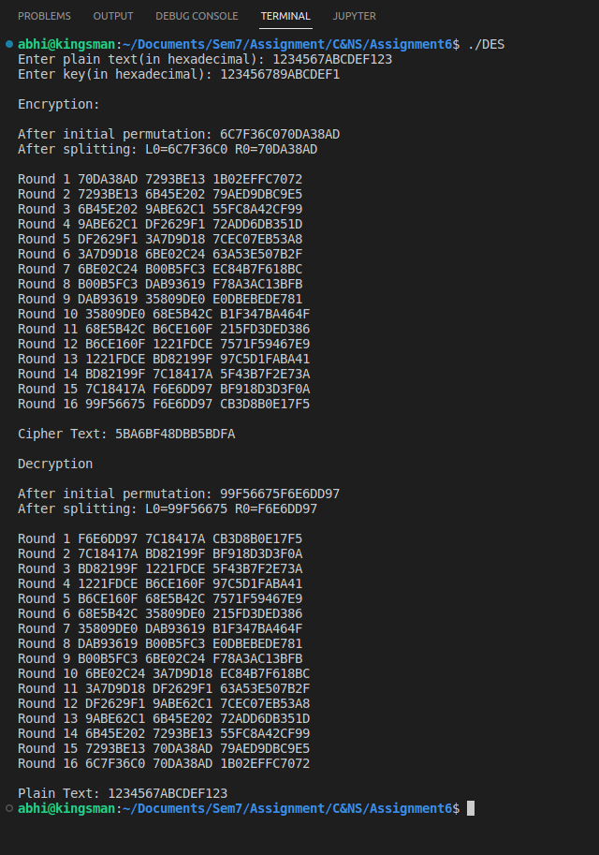

**Conclusion:**

The DES satisfies both the desired properties of block cipher. These two properties make cipher very strong.

1. Avalanche effect − A small change in plaintext results in a great change in the ciphertext.
2. Completeness − Each bit of ciphertext depends on many bits of plaintext.